

**FEE MANAGEMENT**

**Project Team Members:**

**Y. Sai guru Prasad**

**C. Sai Kiran**

**P. Praveen**

**G. Alexander**

**K. Chaitanya Krishna**

**A. Jogeswara Rao**

# DOCUMENT PURPOSE

The project presented here is the FEE MANAGEMENT System. Fee Management system is an integrated students fee based processing system, including inventory, fares, course operations and etc.

**OBJECTIVES**:

* To develop a system to management of fee, this will perform all the functions with a click of mouse button’s
* To develop a system that has good management of data along with integrity and minimizing redundancy.
* To develop a system that will be user friendly in all possible ways.
* To provide better customer support for students.

**HARDWARE AND SOFTWARE REQUIREMENTS:**

**SOFTWARE REQUIREMENTS:**

* Operating system (Windows)
* Apache Tomcat Webserver
* Servlets
* Oracle Database

**HARDWARE REQUIREMENTS:**

|  |  |
| --- | --- |
| **Processor** | : Intel Pentium |
| **Ram** | : 128 MB |
| **Cache** | : 512 KB |
| **Hard** **disk** | : 16 GB hard disk recommended |
|  |  |

**SYSTEM ARCHITECTURE:**

The system will be user friendly and completely menu driven so that the users shall have no problem in using all options.

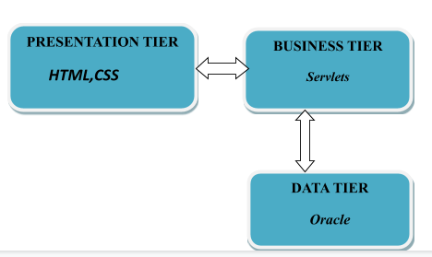

FOR FEE MANAGEMENT SYSTEM:

1. The system will be efficient and fast in response.
2. The system will be customized according to needs.
3. View
4. Add
5. Delete
6. Search

# Module Use case

1. ADMIN SIGN IN MODULE
2. ACCOUNTANT REGISTRATION MODULE

3.ACCOUNTANT SIGN IN MODULE

4.STUDENT REGISTRATION MODULE

1. VIEW INFO
2. FEE INFO
3. DUE INFO
4. SEARCH INFO
5. SIGN OUT MODULE

*1.Accountant registration module:*

In *Accountant registration module*, the User *registration* page is to access the website. If user hasn’t registered, he/she will go to Signup page to create a new account by providing the required detail like,

* Id
* Name
* Email
* Password
* Address
* Contact

After creating the account, the user will Login to the webpage.

*2. Student Registration module*

This module contains a Student form, which are the documents that Students will fill out. It includes the details about the Student, like

* Roll number
* Name
* Email
* Course
* Fee
* Paid
* Due
* Address
* Contact

which they are going to Student.

# *3. Design and Implementation Constraints*

**3.1 Database:**

The system shall use the SQL Database, which is open source and free.

**3.2 Operating System:**

The Development environment shall be Windows10

**3.3 Web-Based:**

The system shall be a Web-based application Hibernate

*4.Define module & Functionality:*

The system functions can be described as follows:

* **Registration:** When the user enters the page, they have to register to visit the website. The Accountant has a separate registration in Admin tab to join as team and get the Access and control.
* **Login:** When Email Id and password is matched it allows the user to dashboard or else it denies the user to enter into website.

.

**Identification of Attributes:**

* Attributes are properties of individual objects. Attributes should not be objects. Use an association to show any relationship between two objects. Attributes usually correspond to nouns to follow by possessive phases. Adjectives often represent specific enumerated attribute values. Attributes are less likely to be fully described in the statement of problem. The knowledge must be drawn from the application domain and the real world to find out the attributes.

|  |  |
| --- | --- |
| **Class** | **Attributes** |
| FEE_ACCOUNTANT | ID, Name, Email, Password,  Address, Contact |
| FEE_STUDENT | Roll no, Name, Email, Course,  Fee, Paid, Due, Address, Contact |

# DFD for Fee Management System

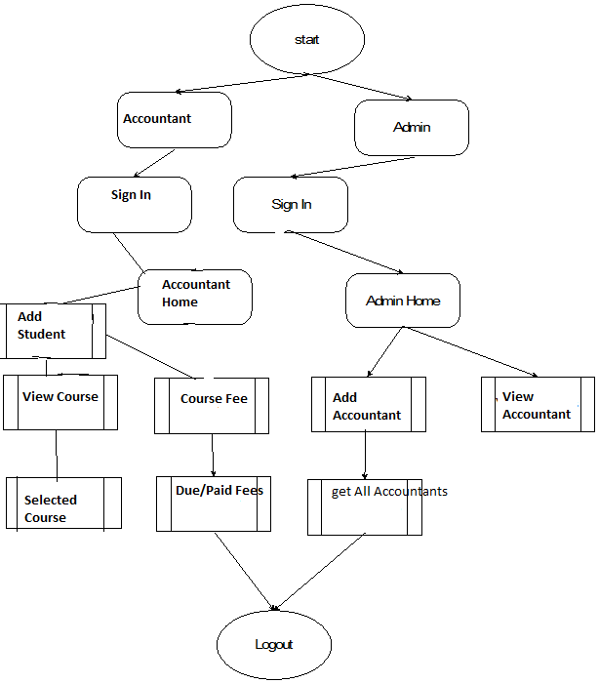

**Schema Diagram:**

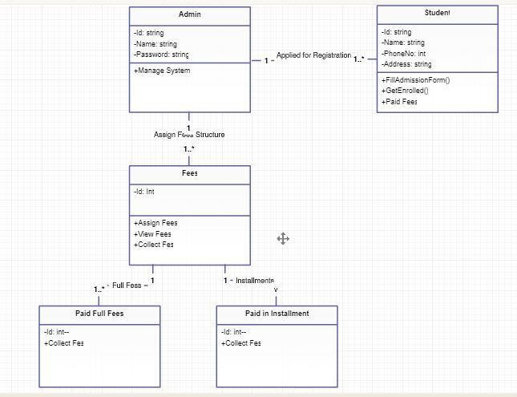

**Use Case Diagram**

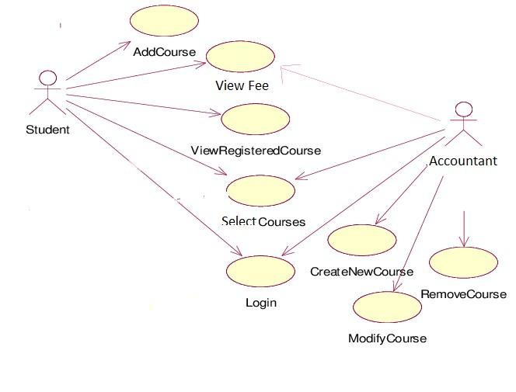

**ER Diagram**

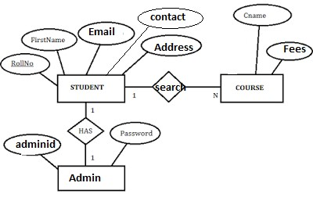

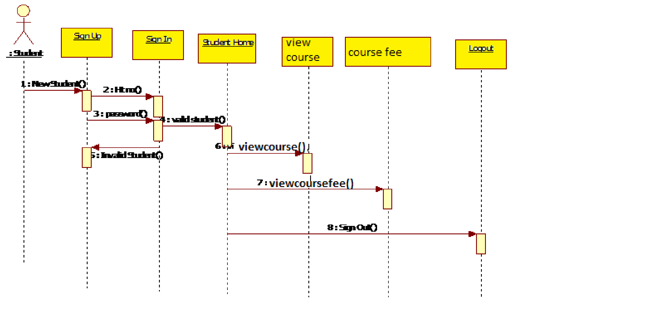**Sequence Diagram**

**Technical:**

1. HTML 5

2. CSS

3. SQL

4. Servlet

5.Validation

**Role for Team Members:**

**Sai Guru and Sai Kiran-UI Design**

***Praveen and Alexander*-Database Access**

**Chaitanya and Jogeswara Rao -** **Schema Design**

**Conclusion:**

Maintaining finance sector in an institution is a challenging task for an official to

perform, since it involves an accountability to parents as as school authorities

about the money invested by them. This module of Fees Management System

System takes care of the entire finance of the institution and manages it effectively, allowing the staff to concentrate on the other important tasks.